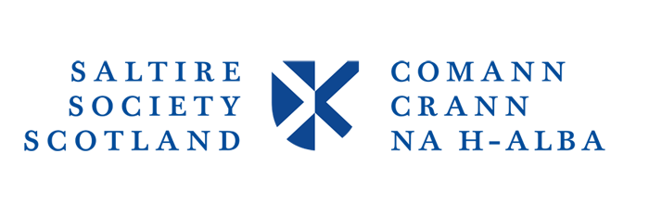
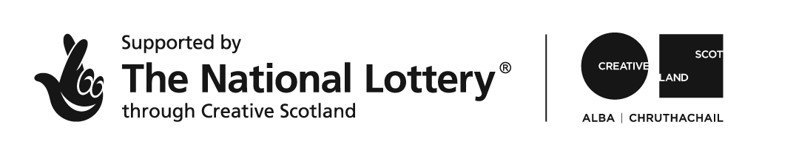

UNDER STRICT EMBARGO UNTIL THURSDAY, 12th OCTOBER AT 19:00 HRS

News Release
2017 Saltire Literary Awards shortlist unveiled at special event in Edinburgh

Multi-award winning writers and household names James Kelman, Bernard MacLaverty and Denise Mina feature alongside emerging talents Ever Dundas and Kate Hunter in 2017 Saltire Literary Awards shortlists, unveiled today (12th October).
The shortlists for the seven awards that make up the 2017 Saltire Literary Awards were officially announced at an event hosted at the Edinburgh West End branch of Waterstones and featured readings from last year’s winner of the Scottish Book of the Year Award, Kathleen Jamie.
Widely regarded as Scotland’s most prestigious book awards, the Saltire Literary Awards are organised by the Saltire Society, a non-political independent charity founded in 1936 which aims to celebrate the Scottish imagination and are supported by Creative Scotland.

Established writer John Burnside, one of only two poets to have won both the T. S. Eliot Prize and the Forward Poetry Prize for the same book, features in both the Poetry and Fiction Book Awards shortlists. He is up against new voices Em Strang and Jason Donald for the coveted prizes.

A collection of some of the most beautiful and historically significant maps from the National Library of Scotland’s archive, the exploration of the development of Muslim communities in Scotland, highlighting the ongoing changes in their structure and the move towards a Scottish experience of being Muslim, and a collection, covering 500 years of transgressive Gaelic poetry with new English translations all contribute to a rich line-up in the Research and Non- Fiction book of the Year Awards.
The Fiction Book of the Year shortlist features a number of acclaimed authors, including the latest novels from previous Saltire Literary Award winners James Kelman, Bernard MacLaverty and John Burnside. Also featured is Denise Mina, the first woman to win the McIllvanney prize for her shortlisted novel, The Long Drop.

The First Book of the Year shortlist is particularly varied, with beguiling historical tale Goblin by Ever Dundas, the interweaving of crime and taxidermy in Sandra Ireland’s Beneath the Skin alongside the candid life-memoir of an Italian Scot, Anne Pia.

2013 saw the Saltire Literary Awards expanded to see Publishers as well as writers celebrated for their work. This year sees awards for both Publishing companies and individuals at the beginning of their career in the industry. Established publishers such as Canongate and Birlinn are shortlisted alongside new comers 404Ink (who have had phenomenal success with their first publication Nasty Women), and niche publishers Handspring.
Emerging talents, such as Kirstin Lamb of Barington Stoke and Laura Waddell of Harper Collins, have been shortlisted for the Emerging Publisher of the Year Award for their commitment, innovation and adaptability within the industry.
The seven awards for the 2017 Saltire Literary Awards, each accompanied by a cash prize for the winner, are:

- The Saltire Society Scottish Fiction Book of the Year Award supported by Creative Scotland;
- The Saltire Society Scottish Non-Fiction Book of the Year Award;
- The Saltire Scottish Research Book of the Year Award supported by the National Library of Scotland;
- The Saltire Scottish Poetry Book of the Year Award supported by the Scottish Poetry Library;
- The Saltire Society Scottish First Book of the Year Award;
- The Saltire Society Publisher of the Year Award;
- The Saltire Society Emerging Publisher of the Year Award; supported by Publishing Scotland;

The winning book from each of the book awards will go on to compete for the coveted Saltire Scottish Book of the Year Award and an accompanying £3,000 cash prize, awarded to Kathleen Jamie for her poetry collection The Bonniest Companie in 2016.

The winners of all the Saltire Literary Awards, along with the Ross Roy Medal for the best PhD thesis on a subject relating to Scottish literature, will be formally announced at a special ceremony in Edinburgh on St Andrew’s Day (30 November).

Saltire Society Programme Director, Sarah Mason commented:

“As always with the Saltire Literary Awards, the sheer scale, diversity and excellence within the shortlists exemplify the best in Scotland’s literary sphere.

“The Saltire Society Literary Awards have a proud history of celebrating and bringing wider attention to excellence in all literary forms and I would like to offer my congratulations to all our shortlisted writers and publishers. I wish them the very best of luck when the awards are announced at a special ceremony on St Andrews day.

ENDS

Notes to Editor
About the Saltire Society

The Saltire Society seeks to encourage everything that might improve the quality of life in Scotland. It works to preserve all that is best in Scottish traditions and to encourage new developments which can strengthen and enrich the country’s cultural life. It acts as a catalyst, celebrant and commentator through an annual programme of awards, lectures, debates and projects. Founded in 1936 is a non-political independent charity with membership branches throughout Scotland.

Membership of the Saltire Society is open to all individuals and organisations that support the aims of the Society. More information can be found here: www.saltiresociety.org.uk

About Creative Scotland
Creative Scotland is the public body that supports the arts, screen and creative industries across all parts of Scotland on behalf of everyone who lives, works or visits here. We enable people and organisations to work in and experience the arts, screen and creative industries in Scotland by helping others to develop great ideas and bring them to life. We distribute funding provided by the Scottish Government and the National Lottery. For further information about Creative Scotland please visit www.creativescotland.com. Follow us @creativescots and www.facebook.com/CreativeScotland
Background to the Awards

The Saltire Literary awards have long been regarded as the country’s most prestigious accolade for authors. We are proud to celebrate and support literary and academic excellence. And now, with a range of new partners and a refreshed style, this suite of awards truly reflects the commitment of civic Scotland to literature in all its forms.

2017 Saltire Literary Awards Shortlists

Saltire Society Scottish Fiction Book of the Year Award, sponsored by Creative Scotland
- Ashland and Vine by John Burnside, published by Jonathan Cape
- Memory and Straw by Angus Peter Campbell, published by Luath
- Midwinter Break by Bernard MacLaverty, published by Jonathan Cape
- Dalila by Jason Donald, published by Jonathan Cape
- The Long Drop by Denise Mina, published by Harvill Secker
- That was a Shiver and Other Stories by James Kelman, published by Canongate
Saltire Society Scottish Non-Fiction Book of the Year Award
- Al Britannia, My Country: A Journey Through Muslim Britain by James Ferguson, published by Transworld Publishers
- Scotland: Mapping the Islands edited by Christopher Fleet, Charles W.J. Withers, and Margaret Wilkes published by Birlinn
- Love of Country by Madeleine Bunting published by Granta Books
- Border: A Journey to the Edge of Europe by Kapka Kassabova, published by Granta Books
- Waypoints: Seascapes and Stories of Scotland's West Coast by ian Stephen, published by Bloomsbury
- The Passion of Harry Bingo: Further Dispatches from Unreported Scotland by Peter Ross published by Sandstone Press Ltd
Saltire Society Scottish Research Book of the Year Award, sponsored by the National Library of Scotland
- The Campbells of the Ark: Men of Argyll in 1745 (Vol I and II) by Ronald Black published by John Donald (Birlinn Ltd)
- Muslims in Scotland: The Making of Community in a Post-9/11 World by Stefano Bonino published by Edinburgh University Press
- History as Theatrical Metaphor by Ian Brown published by Palgrave Macmillan
- The Light Blue Book: 500 Years of Gaelic Love and Transgressive Verse Edited by Peter Mackay & Iain MacPherson, published by Luath
- Immortal Memory: Burns and the Scottish People by Christopher Whatley, published by John Donald (Birlinn Ltd)
Saltire Society Scottish Poetry Book of the Year Award
- Still Life With Feeding Snake by John Burnside, published by Jonathan Cape
- Farm by the Shore by Thomas A. Clark, published by Carcanet
- Bird-Woman by Em Strang, published by Shearsman
- Twist by Pippa Little, published by Arc
- In Search of Dustie-Fute by David Kinloch, published by Carcanet Press
- Moon for Sale by Richard Price, published by Carcanet
Saltire Society Scottish First Book of the Year Award
- Goblin by Ever Dundas, published by Freight Books
- The Case Room by Kate Hunter, published by Fledgling Press Ltd
- Beneath the Skin by Sandra Ireland, published by Polygon
- Language of my Choosing: A Creative Scots- Italian Memoir by Luath
- Mary’s the Name by Ross Sayer, published by Cranachan Publishing
- Fallow by Daniel Shand, published by Sandstone Press Ltd

Saltire Publisher of the Year Award
- 404 Ink
- BHP Comics
- Birlinn
- Canongate
- Handspring
- Vagabond Voices
Saltire Emerging Publisher of the Year Award
- Heather McDaid, 404 Ink
- Kirstin Lamb, Barrington Stoke
- Laura Jones, 404 Ink
- Laura Waddell, Harper Collins

